Internet of Things (IoT)-Based Systems for Classroom Resource Management
Gleiston Guerrerp-Ulloa^{1,2}[0000-0001-5990-2357], Jonathan Villafuerte-Solorzano¹[0000-0002-7801-7369] Michael Yánez-Moreira¹[0000-0003-2297-9064], Miguel J. Hornos²[0000-0001-5722-9816], Carlos Rodríguez-Domínguez²[0000-0001-5626-3115]
¹ State Technical University of Quevedo, Quevedo 120301, Ecuador
² University of Granada, Granada 18014, Spain
{gguerrero, jonathan.villafuerte2014, michael.yanez2013}@uteq.edu.ec}, {mhornos, gleiston@correo.ugr.es, carlosrodriguez}@ugr.es
Abstract. Internet of Things (IoT) is transforming our society and even the way people interact with their environment. In an IoT-based system (IoTS), the identification, authentication and authorization of people and objects is especially important to be able to avoid privacy and security issues. This paper presents an IoTS to control access to classrooms and to efficiently manage their resources (lights and electric/electronic devices). Since the professor scheduled to teach a lesson at a given moment is the only authorized person to open the classroom door, this IoTS identifies that professor through facial recognition, considering a pre-established classroom schedule. In addition, RFID or fingerprint authentication are used to register the attendance of students to a lesson. To develop this IoTS, TDDM4IoTS (Test-Driven Development Methodology for IoT-based Systems) was used. This methodology encourages user engagement during the IoTS development. In fact, professors were involved from the very beginning, especially to improve the design of the mobile application interfaces, finally achieving 100% acceptance by them.
Keywords: Internet of Things, Development Methodology, Access Control, Facial Recognition, Fingerprint Authentication, Classroom Resource Management.
- Introduction
Internet of Things (IoT), a term coined by Kevin Ashton [1], is one of the paradigms that is in continuous development and is being implemented in a wide range of domains [2]. IoT-based systems (IoTS) are the combination of multiple technologies, and it is transforming lifestyles of people, processes, and the way they interact with other people or other systems. Although IoT was initially proposed to refer to interoperable and uniquely identifiable connected objects with radio frequency identification (RFID) technology [3, 4], RFID is currently only one of the technologies used.
IoT represents a holistic environment consisting of many smart devices interconnecting heterogeneous physical objects via the Internet. Many domains, such as logistics, manufacturing, agriculture, home automation, ambient assisted living, smart cities, healthcare, and many other ubiquitous computing applications are the application fields of IoT. By deploying IoTS, the increased interaction between people and things facilitates the exchange of information and services. However, it also poses new challenges, especially in terms of security and privacy [3].
The identification of people or things (entities) in an IoTS, one must consider the reliability that, the entity is the one it claims to be. The mechanism for entity identification with which IoT was born is RFID. However, the use of this technology facilitates identity theft, as the object that identifies them (cards, key fobs, tags, etc.) can be easily exchanged. In this context, there are several alternative identity verification methods, especially for individuals, such as biometric fingerprint identification [5, 6], facial recognition [7], iris recognition [8], among other secure methods.
The identification of authorized persons can facilitate the management of resources (e.g., allowing or denying access to places such as buildings, offices, classrooms, etc.), thus facilitating their use in daily activities to reduce wasted time and increase people's productivity. Resource management used in classroom environments, is one of the fields in which IoT has not been widely applied, especially in developing countries. Among the works that have been presented is that of Chan et al. [9], who proposed a prototype system based on IoT, to control the turning on and off of lights and air conditioning according to the schedules established for a cubicle in the building of professors. Through the objective achieved with this prototype system, energy savings were achieved [9].
In a classroom environment of a higher education institution, it is expected to have, in addition to the lights and air conditioning or heating, the video projector, and of course the entrance control to these environments. In this work we propose a system that aims to control access to classrooms, using devices in an environment such as these when conditions require it. For this purpose, it was implemented, for the opening of the doors, the identification of the authorized person (professor) by facial recognition according to the class schedule. In addition, students are registered by fingerprint.
In particular, the State Technical University of Quevedo, in Ecuador, has some new buildings dedicated to classrooms and administrative offices, in which they started their post-pandemic on-site activities, in addition to the previous buildings due to the increase in the academic offer (increase in the number of careers offered). Staffing needs have grown and, due to the economic crisis the country is going through, it is not feasible to increase the number of personnel. Therefore, one solution would be to automate some tasks, thus avoiding overloading existing staff. In addition, crime has grown exponentially, and although the university's assets have private guards, and there have not yet been any robberies, however, they could occur at any time, since there is no control of people walking into the university's facilities. Therefore, a system that allows authorized persons to enter classrooms (classrooms, computer labs, among others) ensures greater security of classroom assets.
- Related Works
Undoubtedly, the identification of people to access information and enable resources is very important. Mohammad et al., [10], present a system for healthcare management, in which they propose identification using RFID tags and the issuance of digital signatures. The identifier stored on the RFID tag is used to log into a mobile application. Both the physician and the patient are enabled by the RFID tag to use the system, but not to activate any sensor or get any response from any actuator in the system, since the patient is the one providing health monitoring, and the physician is the one issuing notifications or suggestions to the patient.
Another work for the identification of people for access control is the work presented by Guerrero-Ulloa et al. [11], in which they use RDIF cards and tags. This is a system for the care of people with mild cognitive impairment within a home to alert caregivers when the caregiver approaches places that are considered dangerous for these people. Guerrero-Ulloa et al., aware of the impersonation problems that RFID tags and cards can cause, present a system that uses facial recognition for the identification of people in a multipatient medication system from a medication dispenser. Once the system has recognized the patient, it dispenses the medication to be taken at that time [12].
On the other hand, Wang et al. [13], propose a method for worker identification and helmet colour identification based on the detection of moving objects. This system detects moving objects, the region of interest (RoI) of the image is the head of the people who are among those objects. With this RoI, it identifies the worker and the type of work they are doing based on the colour of the helmet they are wearing. In our work we do something similar. The face of the person in front of the camera is detected, this being for our case the RoI, with a resolution of 8 bits in grayscale. This RoI is used to recognize the person. The goal of Wang et al., it is to detect that the worker is wearing the case on the head and identify the colour of the helmet, while one of goal of our work is to recognize who is the person in front of the camera, and according to the established restrictions give or deny access to classroom.
Another objective of this proposal is that lights and equipment used in the classroom environment will remain on only if there are people in the classroom, and, in the case of lights and air conditioning specifically, will be turned on or off as needed depending on the light and temperature weather conditions at the time [4]. And, of course, the professor will be able to make the best decisions while in the classroom environment. In all cases, when there are no people in the classroom, the equipment is automatically turned off. In addition, to reduce electrical energy consumption in UTEQ classrooms or similar environments, i.e., where the use of electrical devices is not adequately controlled.
- Proposed system
The proposed system is a classroom access control system (SISGERA for its acronym in Spanish: Sistema de Gestión de Recursos de Aula). SISGERA is intended to achieve two objectives: to support the service personnel in charge of controlling access to the classrooms and the use of electrical and electronic devices (lights, air conditioners, video projectors) installed in the classrooms.
SISGERA was implemented in classroom FCI-008. This classroom, like any other, has a schedule of use from Monday to Friday from 07H30 to 20H30, mostly with 2-hour intervals. The use of the classrooms is per module. Each module consists of 25 to 30 hours of class per week. An example of a schedule of use is for Classroom FCI-008 is used to teach the nineth module of the Mechanical Engineering career, morning shift:
- Monday from 07:30 to 10:30 and from 10:30 to 12:30
- Tuesday from 07:30 to 10:30 and from 10:30 to 12:30
- Wednesday from 09:30 to 12:30
- Thursday from 07:30 to 10:30 and from 10:30 to 12:30
- Friday from 09:30 to 11:30 and from 11:30 to 12:30
Meanwhile, in the same classroom (FCI-008), classes are given for the eighth module of the Environmental Engineering career, afternoon shift:
- Monday from 13:30 to 15:30 and from 15:30 to 17:30
- Tuesday from 12:30 to 14:30 and from 14:30 to 17:30
- Wednesday from 12:30 to 14:30 and from 14:30 to 17:30
- Thursday from 13:30 to 16:30 and from 16:30 to 17:30
- Friday from 12:30 to 13:30, from 13:30 to 14:30, and from 14:30 to 17:30
The approximate ravel time of a professor to the corresponding classroom is between 5 and 15 minutes. Therefore, the time that the equipment will remain on (air conditioners and video projectors) without use will be 95 and 285 minutes per day, not to mention, the days that morning students finish their classes ahead of the start students of the afternoon classes. The latter situation can cause lights and equipment to remain on for hours unnecessarily. In addition, on days when the students of the module have classes in other environments such as computer labs, applied physics labs, among others (depending on the career) so they must leave the classrooms and move around, leaving these devices on and, in some cases, also the lights.
  - Development of SISGERA
For the development of SISGERA, the test-driven development methodology for IoT-based systems (TDDM4IoTS) was used [14]. Since it is the only methodology found in the literature that emphasizes the specific activities of IoT-based systems, such as the analysis of the environment in which the system will be deployed, the design of the technology layer (hardware and software), among others [15]. In addition, it leverages Test Driven Development (TDD) to obtain the necessary software.
TDDM4IoTS is a methodology based on the values and principles of the agile manifesto. It defines 4 roles for the project team members, the user role and the project facilitator role were played by the first author (professor of the UTEQ), and the development team was played by the second and third authors. The activities that TDDM4IoTS considers should be carried out in the development of an IoTS are grouped in 11 stages, namely: (1) Preliminary analysis, (2) Technology layer design, (3) Detailed requirement analysis, (4) Model generation and adaptation, (5) Test generation, (6) Software generation, (7) Model refinement, (8) Software refinement, (9) Hardware and software deployment, (10) Deliverable assessment, (11) Maintenance. These phases are not strict in nature. Especially in small projects like the one presented in this paper, the TDDM4IoTS phases that were not executed until the delivery of the finished system were: model refinement and maintenance. In addition, other phases have only been executed once such as: the preliminary analysis stage and the technology layer design stage, and the software refinement stage that was executed with the last deliverable, as mentioned by the authors of TDDM4IoTS.[14].
The Fig. 1 shows the stages of TDDM4IoTS and the order in which they were executed in the development of SISGERA because it is a relatively small system.
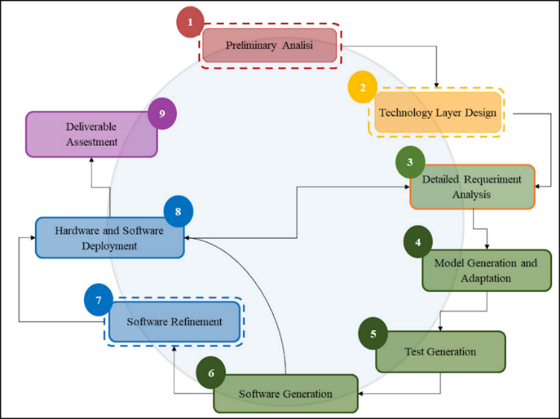
Fig. 1. TDDM4IoTS stages and order of execution.
  - Results of the methodology
This subsection presents the results of the execution of each of the phases of the methodology that were necessary due to the dimensions of the project.

(1) Preliminary analysis. Some of the authors, as actors (students and professors) of the daily activities that take place in the university facilities where the system will be implemented, know the basic needs, and through direct observation and interviews with the dean of the Faculty of Engineering Sciences of the UTEQ, the specifications or requirements that the system must meet have been determined.
SISGERA must meet the following functional requirements:
- Keep the lights, air conditioning and video projector off when there are no people in the classroom.
- Facilitate access to the classroom for the professors according to the schedule established for this purpose.
- Authentication of the professor and students entering the classroom should be one of the most secure methods to ensure that the person entering is who he/she claims to be.
- When the professor can enter the classroom, the lights, air conditioning and video projector should be turned on (in that order).
- The professor must be able to control the equipment (turn it off and/or on).
- The professor can enter the classroom according to a schedule established for the academic cycle or occasionally.
- Student attendance must be recorded in the system at the time they identify themselves for entry.
One of the tools proposed by TDDM4IoTS to capture the coarse-grained requirements of a system are use case diagrams. The Fig. 2 shows the SISGERA use case diagram.
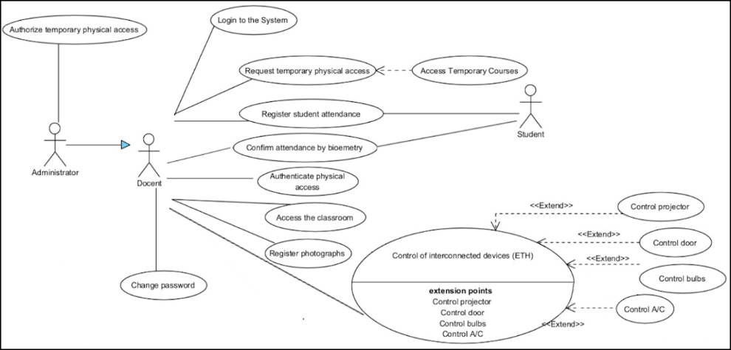
Fig. 2. Use case diagram of SISGERA.
Regarding the non-functional requirements of the system, it was determined that, as it is a system to be deployed in a classroom, the power supply is guaranteed by the public utility. As for the Internet connection, a permanent WiFi connection is available. In addition, the system must be as economical as possible, without neglecting quality and security.
The technology for the implementation of SISGERA is popular and commercially available. The hardware elements required are: Raspberry PI for local processing and for sending data to the Internet, Arduino mega to treat the signals captured by the sensors and send the data to the Raspberry PI through the Bluetooth module, infrared sensors for turning on and off the controlled equipment, IP camera to capture the video that serves for the recognition of people, RFID card reader, RFID cards to identify students at the time of entry, fingerprint reader to identify students more securely (when required), motion sensor to detect inside the classroom, relay modules to control the on and off of lights, air conditioner, among the most important.
For face recognition, an OpenCV-based approach has been used (1) capturing the face of the person (professor) using an IP camera and sent using the real-time control protocol (RTCP). (2) Face detection is performed from a Live Stream using the Haar cascade classifier, which is based on the Viola-Jones framework available in OpenCV. (3) Finally, for face recognition, the LBPH algorithm has been used as it provides better results in different lighting conditions, light rays and pose variations. And according to this, it returns the ID of the person with the best similarity.
The results of the feasibility study warranted the development of SISGERA. The cost of development and implementation is economical. The project team has the experience and academic background that fits the profile required for the development of IoTS. The estimated development time is within the expected timeframe. Finally, regarding the operational feasibility, being a system for a university that offers careers such as Systems Engineering, Software and Telematics, it has trained personnel to keep this system operational.

(2) Technology Layer Design. The two outputs of this stage were (1) the system architecture (see Fig. 3) and (2) the device or hardware design (see Fig. 4).
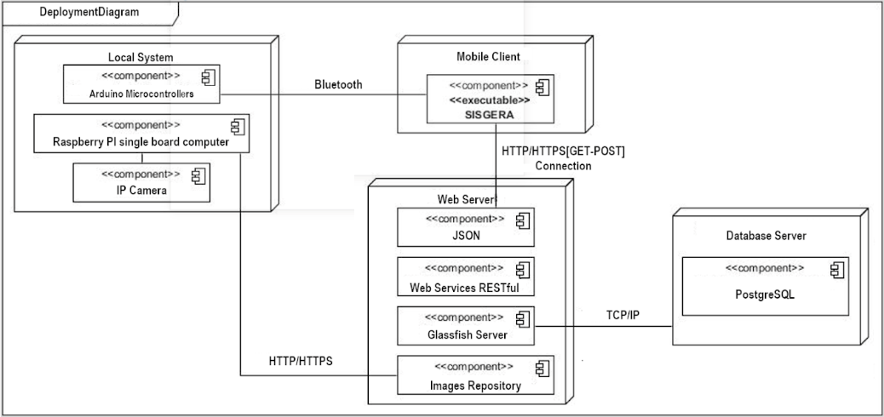
Fig. 3. Architecture of proposed system.
The local system is responsible for processing the information captured in the environment, such as facial recognition of the professor and fingerprint identification of the students, as well as executing commands to control the equipment, among other tasks. The local system connects via Bluetooth with the mobile application to execute the commands sent by the professor, and with the web server to store and retrieve the data to/from the PostgreSQL database. The web server is prepared to serve the mobile application delivering the requested information through RESTful web services, for this purpose, this server connects via TCP/IP protocol with the PostgreSQL database server.
The interconnection of the sensors, actuators and single board computers that were used in the SISGERA device is shown in Fig. 4: (1) Siemens DC Breaker 220/380V, (2) Merlin Gerin C60hb Multi9 B25 Circuit Breaker, (3) Electric lock transformer 110V-12V, (4) Power strip, (5) Door control, (6) Electric sheet DC motor, (7) Bluetooth HC-5 module, (8) Arduino mega 2560, (9) Protoboard, (10) Relay module 2 channels, (11) HC-SR04 PIR module, (12) 4-channel relay module, (13) Male and female DC Power Jack Socket adapter cable, (14) Wiegand W26 RFID reader, (15) DFRobot fingerprint reader sensor, (16) NE555 IR transceiver module, (17) Raspberry Pi 4, (18) IP camera, (19) Router (Wi-Fi Service).
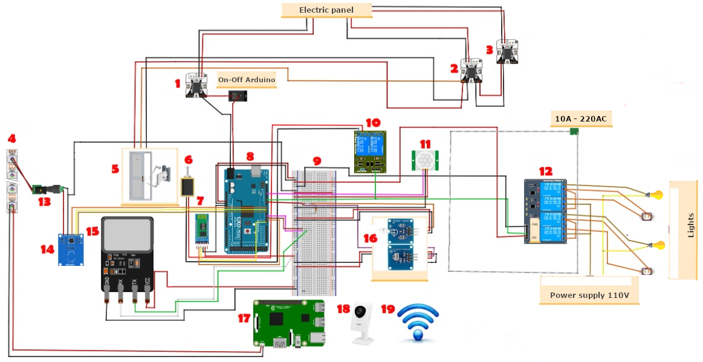
Fig. 4. Design of the proposed system device.
This stage established the roadmap for the execution of the other activities of the remaining stages.

(3) Detailed requirement analysis. For each of the deliveries into which the proposed system was divided, the requirements were analysed in detail to obtain the tests that the software must pass, thus ensuring that the system meets the requirements demanded by the client. Semi-structured use cases were used to collect the requirements that the customer demands that the system must meet. Table 1 shows an example of a use case.

(4) Model Generation and Adaptation. IoTS are heterogeneous in nature, so it is very important to obtain a platform-independent model before generating a platform-specific model with the system software. The Fig. 5 shows a part of the class diagram representing the system model.
Table 1. Example of use case (Confirm attendance).
Use case: |  | Confirm attendance
Actor: | Student, professor
Purpose: | Corroborate of the student presence through the registration of fingerprints.
Summary: | The professor, for some reason, needs to corroborate the attendance of the students by registering fingerprints (initially he should have done it through his RFID card).
Type: | Secondary.
Main Section
Normal Flow of Events
Action of Actors |  |  |  |  | System Response
1. The use case begins when the professor needs to verify the attendance of a student, for which he/she will proceed to change the attendance status of the student to be verified.
2. Ask the student to place his thumb on the fingerprint sensor.
 |  |  | 3. The fingerprint sensor captures the fingerprint and compares it with those registered in the database. Placing the respective student's attendance record.
4. The professor presses the "update" button to observe the changes made after corroboration.
 |  |  | 5. The corresponding user interface is displayed, where the student attendance list is updated.
6. The professor finalizes his corroboration with the other students, if any, and proceeds to send the attendance to the database by clicking on the "Register attendance" button.
 |  |  | 7. Displays the confirmation message.
8. Accepts the confirmation of the data to record the student's attendance.
 |  |  | 9. Displays the success message, updates the list of students with their respective attendance and locks the "Register attendance" button.
10. If there are more attendance observations, repeats the step 2 with the next student for his identity verification; and ends the use case.
Alternate flows
Line 3: Fingerprint not recognized, return to line 2.
Line 4: Update failed, return to line 2.
Line 7: Reject confirmation and return to line 5.
List of Methods
Method Signature |  |  |  | Purpose of the Method |  |  |  | Affected Tables
public fnUpdateAttendeceByBiometric (in_biometric text) |  |  |  |  |  | Record the attendance of the student who places his/her thumb on the fingerprint sensor.
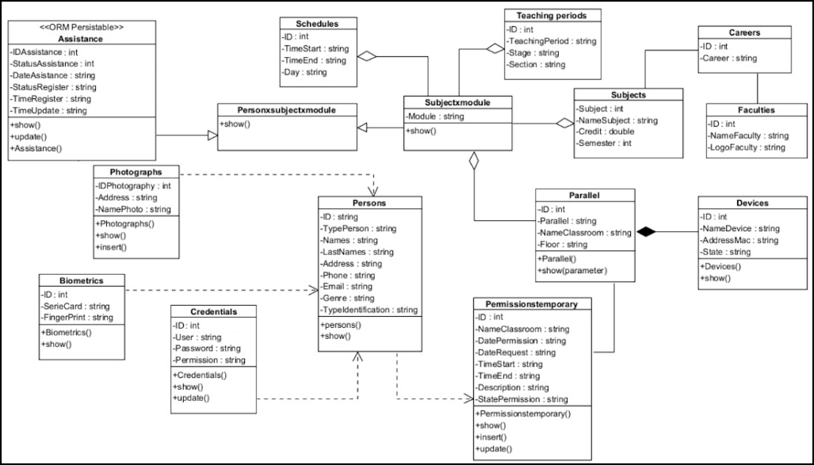
Fig. 5. Classes Diagram of SISGERA.

(5) Test generation. Tests were obtained with the customer for each functional requirement and its different scenarios that could occur. Below are the tests for the functional requirement where SISGERA must keep the classroom lights and equipment off.
The condition is given that both lights and equipment are turned off.
- A professor who is scheduled to teach in classroom FCI-008 on Mondays at 10:30 in classroom FCI-008, arrives on the correct day but at 10:00. The system informs him that it is not time for his class and keeps everything turned off.
- A person who does NOT teach in classroom FCI-008, goes to this classroom, the system informs him that he has no classes scheduled in classroom FCI-008.
- A professor who is in the classroom leaves the classroom. When leaving the classroom of leaving, both the equipment and the lights are on. The last person to leave the classroom must close the door (whether he/she closes it or not), the system turns off the lights and equipment.
- A professor who is in the classroom leaves the classroom. When leaving the classroom of leaving only the lights are on. The last person to leave the classroom must close the door (whether he/she closes it or not), the system turns off the lights and the equipment remains off.
- A professor who is in the classroom leaves the classroom. When leaving the classroom of leaving, he/she makes sure that both lights and equipment are turned off. The last person to leave the classroom must close the door (whether he/she closes it or not), lights and equipment remain off.
- A professor who is in the classroom leaves the classroom. When leaving the classroom, only the air conditioning is on. The last person to leave the classroom must close the door (whether he/she closes it or not), the system turns off the air conditioning, and the lights and video projector remain off.
- A professor who is in the classroom leaves the classroom. When leaving the classroom, only the video projector is on. The last person to leave the classroom must close the door (whether he/she closes it or not), the system turns off the video projector and the lights and air conditioning remain off.
- A professor who is in the classroom leaves the classroom. When leaving the classroom, only the lights are off. The last person to leave the classroom must close the door (whether he/she closes it or not), the system turns off the air conditioning and the video projector, and the lights remain off.
The tests of the mobile application consist of the manipulation of the air conditioning, video projector and lights. In addition, it is verified that the data captured by the sensors and those generated by other operations of the application users (such as user creation, password modification, confirmation of student attendance, among others) are correctly stored in the database.

(6) Software generation. It is a most important stage. This is the most important stage. As mentioned in TDDM4IoTS, this process can be manual or automatic. For the automatic generation of the software, Visual Paradigm was used, being this same tool the one used for the elaboration of the class diagram.
Viual Paradigm generated a file for each class with its definition (class with its attributes and method definitions) to be used in the mobile application. 100% of the Arduino code, and the rest of the business logic code was written by the development team. The Fig. 6 shows the results of one of the exposed conditions (lights and equipment initially turned on) when running the software to pass these tests.
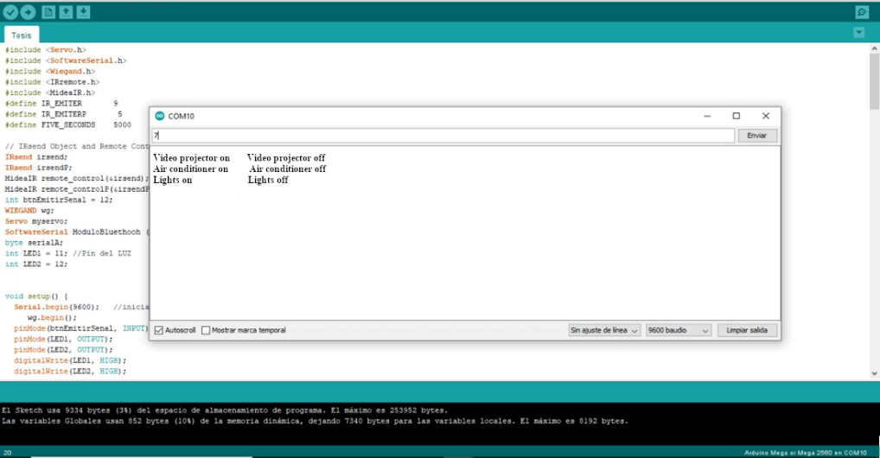
Fig. 6. Execution of tests - Turn off lights and equipment.

(7) Software Refinement. This stage of TDDM4IoTS was executed only once, after obtaining the mobile application software from SISGERA. It was not necessary to refactor the device configuration software, as it was written by only one of the development team members, considering from the beginning the guidelines to obtain a clean code. Overall, it was the shortest stage with little work for the developers.

. (8) Hardware and software deployment. The deployment of the hardware took considerable time compared to the rest of the activities. Locksmith work was performed to embed a secure electric lock in the entrance door, install the infrared emitters at a safe distance from the air conditioner and video projector so that the signal from the emitters would not be obstructed. In addition, securing the camera in the hallway, so that malicious persons would not remove it from its location.
The deployment of the mobile application and database, due to its nature is not considerable work. Ideally, the mobile application would have consumed the web services of the university's academic management system; however, since it was a prototype and sensitive information, a rough database was created to feed and be fed by the system. The Fig. 7 shows the screenshots of the SISGERA mobile application. figure Fig. 7(a) shows the results of the query of the students who have registered their entry to the classroom. Fig. 7(b) shows the screen used by the teacher to request a classroom outside his assigned schedule. Fig. 7(c) shows the interface to control the classroom equipment.

(a) Registered students (b) Request classroom (c) Equipment control
Fig. 7. Screenshots of the SISGERA mobile application.

(9) Deliverable assessment. The usability evaluation of SISGERA was done at several points in time. At the initial stage, there were many negative comments and a generally negative rating (7 out of 10). Following these results, users (professors) were involved in the design of the mobile application interfaces, to implement improvements. These improvements resulted in 100% acceptance by professors. The Fig. 8 shows the results of the usability evaluation of the proposed prototype system.

Fig. 8. Results of usability evaluation of SISGERA at five moments
- Conclusions
The use of a specific methodology for IoTS development helps to obtain a system that meets the functional requirements specified by the customer and considers the non-functional requirements of each IoTS. TDDM4IoTS is a more effective guide for IoTS developers, especially those who do not have sufficient experience in IoTS development.
The use of facial recognition as a user authentication method is one of the most secure, although its response time is slightly longer than traditional methods, such as password authentication. However, when high levels of security are required, facial recognition authentication time is acceptable. Another secure authentication method is fingerprint authentication. Although the time it takes to identify fingerprints is less than that of facial recognition. However, in our case, RFID authentication is used for students because it is a faster method, and the number of users is considerable (from 15 to 45 students). In addition, the teacher knows his students, and in case he does not know them and doubts their identity, he can use the mobile application to ask the student to confirm his attendance using the fingerprint authentication method.
For a software application to be successful, the user must be involved in its design, especially in the design of its interfaces. The more the user participates in this process, the greater the acceptance of the application.

References
1. Ashton, K.: That ‘Internet of Things’ Thing. RFID journal. 22, 97–114 (2009).
2. Pan, J., Jain, R., Paul, S., Vu, T.: An Internet of Things Framework for Smart Energy in Buildings: Designs, Prototype, and Experiments. IEEE Internet of Things Journal. 22, xix–xxvi (2012). https://doi.org/10.1109/JIOT.2015.2413397.
3. Atzori, L., Iera, A., Morabito, G.: The Internet of Things: A survey. Computer Networks. 54, 2787–2805 (2010). https://doi.org/10.1016/j.comnet.2010.05.010.
4. Tragos, E.Z., Foti, M., Surligas, M., Lambropoulos, G., Pournaras, S., Papadakis, S., Angelakis, V.: An IoT based intelligent building management system for ambient assisted living. 2015 IEEE International Conference on Communication Workshop, ICCW 2015. 246–252 (2015). https://doi.org/10.1109/ICCW.2015.7247186.
5. Golec, M., Gill, S.S., Bahsoon, R., Rana, O.: BioSec: A Biometric Authentication Framework for Secure and Private Communication among Edge Devices in IoT and Industry 4.0. IEEE Consumer Electronics Magazine. 11, 51–56 (2022). https://doi.org/10.1109/MCE.2020.3038040.
6. Bedari, A., Wang, S., Yang, J.: A Two-Stage Feature Transformation-Based Fingerprint Authentication System for Privacy Protection in IoT. IEEE Transactions on Industrial Informatics. 18, 2745–2752 (2022). https://doi.org/10.1109/TII.2021.3101208.
7. Sadiq, M., Shi, D., Liang, J.: A Robust Occlusion-Adaptive Attention-Based Deep Network for Facial Landmark Detection. Applied Intelligence 2021 52:8. 52, 9320–9333 (2022). https://doi.org/10.1007/S10489-021-02848-8.
8. Francese, R., Frasca, M., Risi, M.: Are IoBT services accessible to everyone? Pattern Recognition Letters. 147, 71–77 (2021). https://doi.org/10.1016/J.PATREC.2021.04.007.
9. Chan May, O.A., Sandoval Gio, J., Peña Koo, J.J.: Internet of Things to Control the On/Off Switching of Air Conditioners and Light Fixtures. Pistas Educativas. 38, 100–119 (2016).
10. Mohammad, G.B., Shitharth, S., Syed, S.A., Dugyala, R., Rao, K.S., Alenezi, F., Althubiti, S.A., Polat, K.: Mechanism of Internet of Things (IoT) Integrated with Radio Frequency Identification (RFID) Technology for Healthcare System. Mathematical Problems in Engineering. 2022, (2022). https://doi.org/10.1155/2022/4167700.
11. Guerrero-Ulloa, G., Rodríguez-Domínguez, C., Hornos, M.J.: IoT-Based System to Help Care for Dependent Elderly. Communications in Computer and Information Science. 895, 41–55 (2018). https://doi.org/10.1007/978-3-030-05532-5_4.
12. Guerrero-Ulloa, G., Hornos, M.J., Rodríguez-Domínguez, C.: IoT-Based Smart Medicine Dispenser to Control and Supervise Medication Intake. In: Iglesias, C.A., Moreno Novella, J.I., Ricci, A., Rivera Pinto, D., and Roman, D. (eds.) Ambient Intelligence and Smart Environments. pp. 39–48. IOS Press, Madrid, España (2020). https://doi.org/10.3233/AISE200021.
13. Wang, S., Li, X., Chen, W., Fan, W., Tian, Z.: An Intelligent Vision-Based Method of Worker Identification for Industrial Internet of Things (IoT). Wireless Communications and Mobile Computing. 2022, (2022). https://doi.org/10.1155/2022/8641096.
14. Guerrero-Ulloa, G., Hornos, M.J., Rodríguez-Domínguez, C.: TDDM4IoTS: A Test-Driven Development Methodology for Internet of Things (IoT)-Based Systems. Communications in Computer and Information Science. 1193 CCIS, 41–55 (2020). https://doi.org/10.1007/978-3-030-42517-3_4.
15. Guerrero-Ulloa, G.G., Hornos, M.J., Rodríguez-Domínguez, C., Fernández-Coello, Ma.M.: IoT-Based Smart Medicine Dispenser to Control and Supervise Medication IoT-Based Smart Medicine Dispenser to Control and Supervise Medication Intake. Medication Intake. (2020).

